AKGEC/IAP/FM/02
AJAY KUMAR GARG ENGINEERING COLLEGE, GHAZIABAD

DEPARTMENT OF MECHANICAL ENGINEERING

SESSIONAL TEST-2

Course : B. Tech. Semester: V
Session: 2017-18 Section : ME1, ME2, ME3
Subject : Machine Design-I Subject Code: NME-501
Max. Marks: 50 Time: 2 hours

Note:-- Attempt All questions. Use of design data book is permitted. Any missing data may be assumed.
SECTION-A

Attempt all the questions (5x2 = 10)

  - What is notch sensitivity?
  - What are the methods of reducing stress concentration?
  - Describe types of riveted joint. Also explain the various failure modes of rivets.
  - Compare the strength of a hollow shaft with that of a solid shaft of same diameter and material of the diameter ratio of 0.8.
  - Explain the function the key. Define woodruff key.

SECTION B

Attempt all the questions (5 x 5 = 25)

  - A shaft is subjected to bending moment varying from -200 Nm to +500 Nm and a varying torque from +50 Nm to +175 Nm. If material of the shaft is 30C8, stress concentration factor is 1.85, notch sensitivity factor is 0.95, reliability 95% and factor of safety is 1.5, find the diameter of the shaft.
  - A bracket is riveted to a column by 6 rivets of equal size as shown in following figure. It carries a load of 100 kN at a distance of 250 mm from the column. If the maximum shear stress in the rivet is limited to 63 MPa, find the diameter of the rivet.
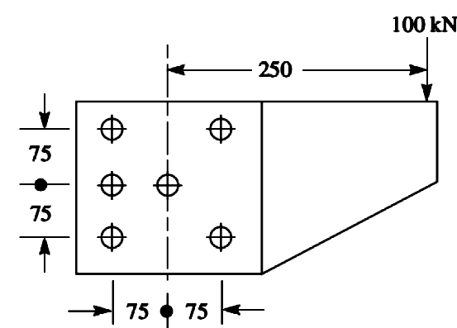
  - A component machined from a plate made of steel 45C8 (Sut = 600 MPa) is shown in fig. Its subjected to a completely reversed axial loading of 50 kN. The expected reliability is 90% and the factor of safety is 2. The size factor is 0.85. Determine the plate thickness t for infinite life, if the notch sensitivity factor is 0.8.
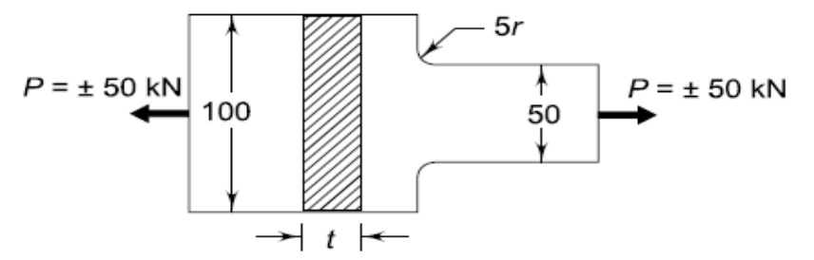
  - A solid shaft is subject to a bending moment of 3.46 kN-m and torsional moment of 11.5kN-m. The shaft is made of 45C8 steel and factor a safety is 6. Find the diameter of shaft.
  - Define the efficiency of riveted joint? A longitudinal joint for a boiler is to be designed for a steam pressure of 2.5 MPa with an efficiency of 85%. The inside diameter of the largest course of the drum is 1.35 meter. The allowable stresses may be taken as in tension = 78.0 MPa, in shear 62.5 MPa, in crushing = 135.0 MPa.

SECTION C

Attempt all the questions (2x7.5 = 15)

  - Design a cast iron flange coupling for a mild steel shaft transmitting 90 kW at 250 r.p.m. The allowable shear stress in the shaft is 40 MPa and the angle of twist is not to be exceed 1º in a length of 20 diameters. The allowable shear stress in the coupling bolts is 30 MPa.
  - The layout of transmission shaft carrying two pulleys B and C and supported on bearings A and D as shown in figure. Power is supplied to the shaft by means of a vertical belt on pulley B, which is then transmitted to pulley C carrying a horizontal belt. The maximum tension in belt on pulley B is 2.5 kN. The angle of wrap for both the pulleys is 180⁰ and coefficient of friction 0.24. The shaft is made of plain carbon steel 30C8 (S_{yt} = 400 N/mm²) and the factor of safety is 3. Determine the shaft diameter on strength basis.
